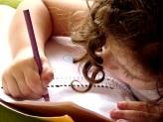  Literacy and WCR  In Talk 4 Writing, this half term, Year 3 will be exploring the genre of a warning story. We will be writing our own meeting story focusing on the key literary devices to help set the scene.  Year 5 will be reading an all-time children’s classic – “The Iron Man” and “Escape from Pompeii”. | Maths  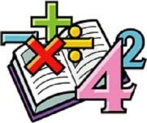  In Maths, we will be looking at place value. Towards the end of the half term, Year 3 will be looking at using addition and subtraction to solve problems.  We will begin to develop our arithmetic skills to make sure we keep practising key skills. | Science  In Science, this half-term, we will be looking into the topic “Rocks”  This includes looking at their properties, conducting experiments and classifying them. | Computing  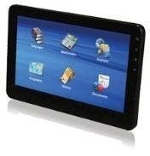  In Computing, Year 3 will be looking at how they can keep themselves safe online and becoming online safety experts.
Humanities  In History, Year 3 will be looking into the Romans and their empire. Year 3 will be looking into the impact of the Romans and how their inventions and innovations are still used today. Year 3 will identify significant figures of this era and delve deep into their legacy. | Overdale Community Primary School  Year 3 Autumn 1 – 2023  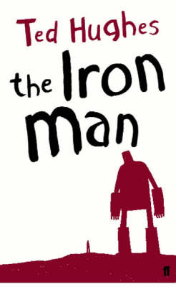  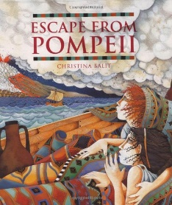 |  | 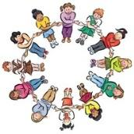  RHE/PSHE  This term in PSHE, Year 3 will be looking at family and friendships.  Year 3 will be sharing our worries, friendship hiccups and working on what makes a good friend and citizen.
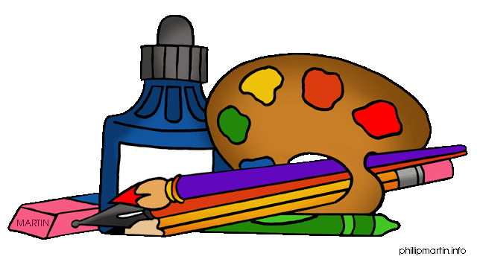  Art and DT  In DT, we will be looking at how to create a structure using 3D nets.  In Art, Year 3 will be exploring a variety of art and craft projects to build on our experiences with different art techniques. | PE  This term in PE, we will be learning a 16-32 count dance routine to represent the Roman army.  We will also be practising our orienteering skills. | 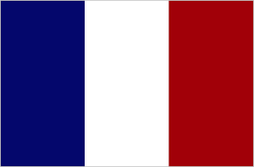  French  In French, we will be looking at how we introduce ourselves as a start to our language learning journey.  Music  In Music, Year 3 will be looking at how traditional Indian music is made and perform it through musical notation. | RE  In RE, we will be looking at a key question.  Our key question this half term is:  “What does it mean to be a Christian in Britain today?”

Reading: Children will be expected to read their home reading books three times a week with a written comment from a parent in their reading record. Books will be changed when children complete a book review of their current reading book or in a phonic session.
Maths: Children will be tested on their times tables throughout the week as well as a weekly arithmetic test to build their mental arithmetic confidence.
Spelling: We will do a weekly spelling test every Friday. Children will be given a new spelling sheet to practise their spellings weekly. At first, we will concentrate on high frequency words and then introduce the class to the LKS2 spellings.
Foundation subjects: At the end of every term, children may bring in any work they would like to showcase that they have completed additionally to their foundation subjects. E.G. Roman soldier, building a Roman town or any structures similar to our DT topic.

